CaseManagement_CreationOfCase_Instance23_06-Aug-2018_02-54-23_AM_MouseClickActionMoveToElementByxpathimgaltServiceparentspan.png

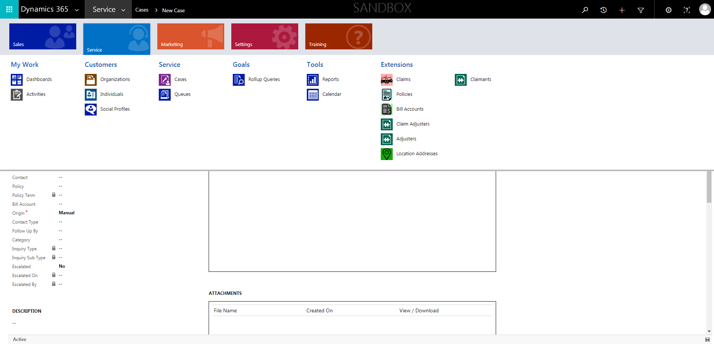

CaseManagement_CreationOfCase_Instance23_06-Aug-2018_02-54-01_AM_SingleSignOn.png

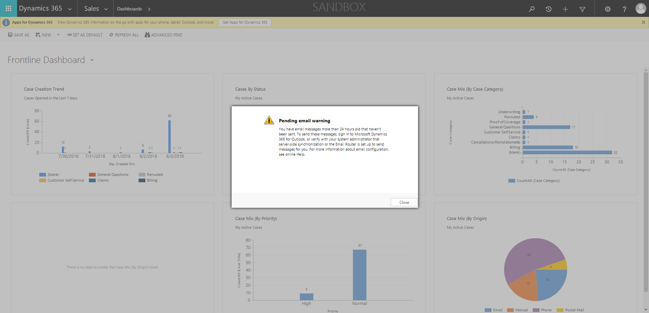

CaseManagement_CreationOfCase_Instance23_06-Aug-2018_02-54-09_AM_MouseClickActionMoveToElementBycssSelectoranavcases.png

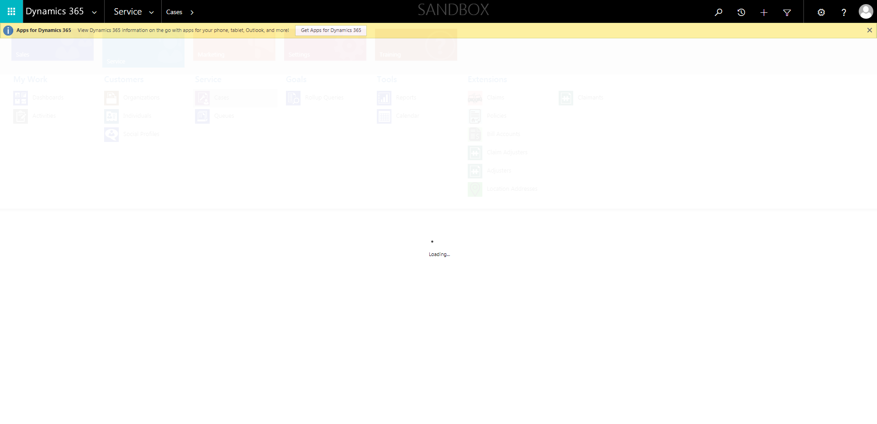

CaseManagement_CreationOfCase_Instance23_06-Aug-2018_02-54-22_AM_MouseClickActionMoveToElementBycssSelectorspanTabCS.png

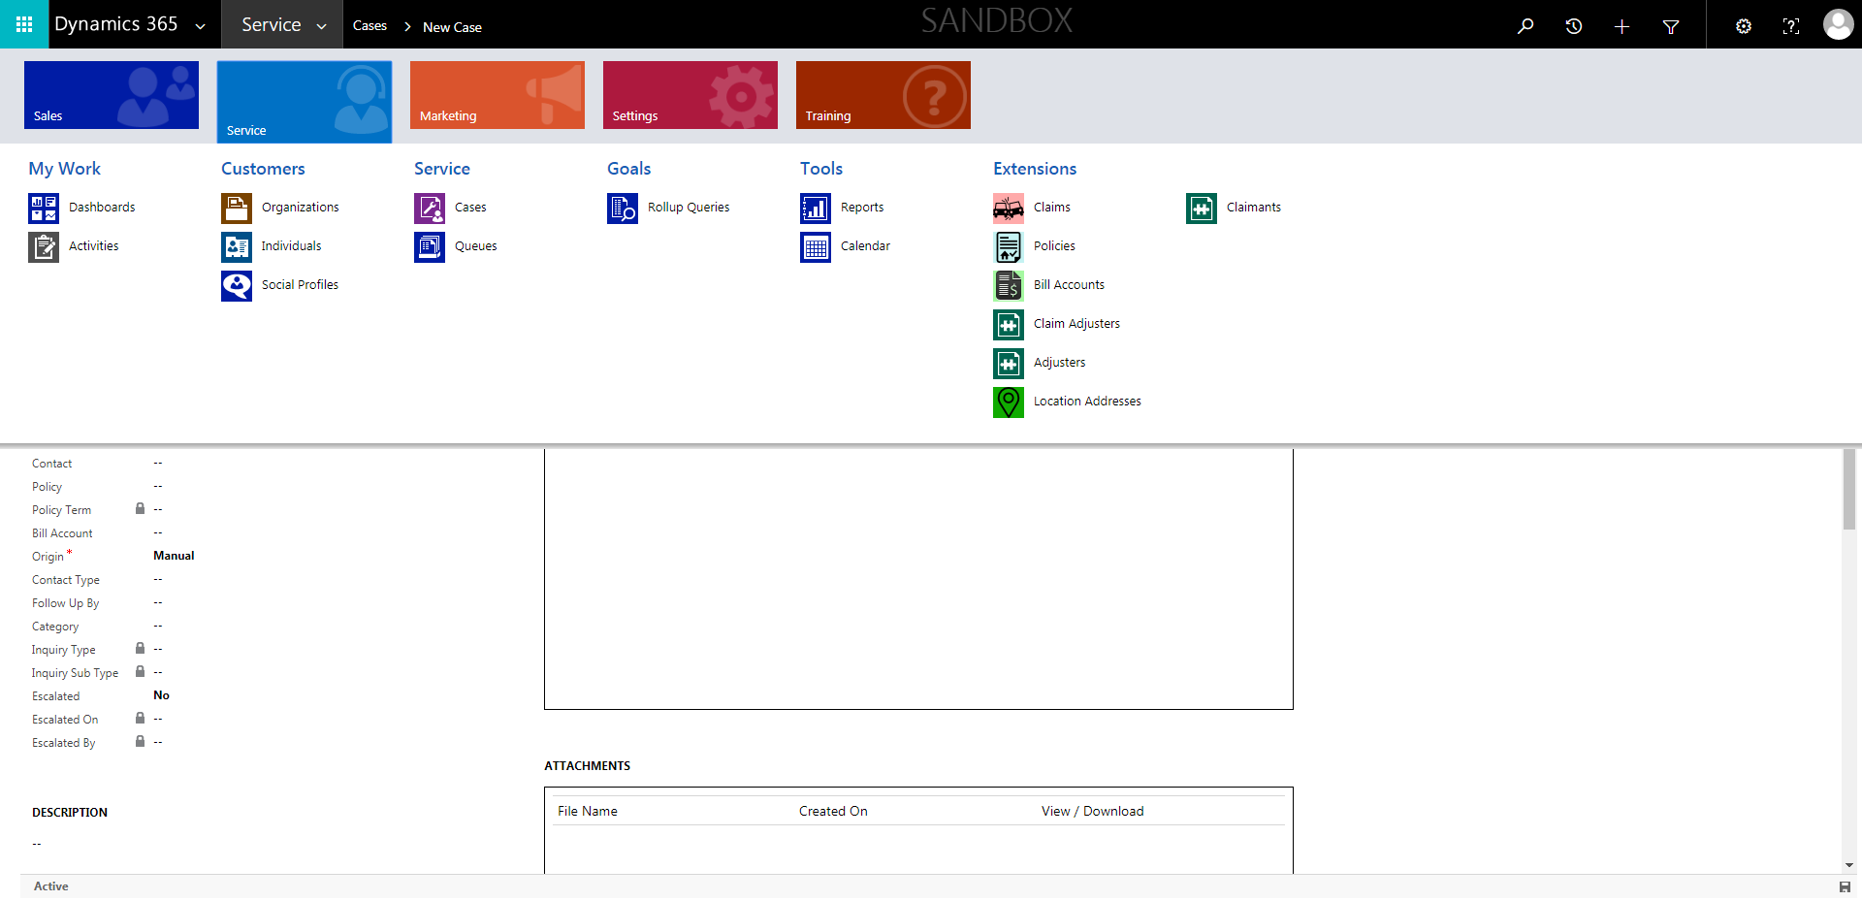

CaseManagement_CreationOfCase_Instance23_06-Aug-2018_02-54-03_AM_SingleSignOn.png

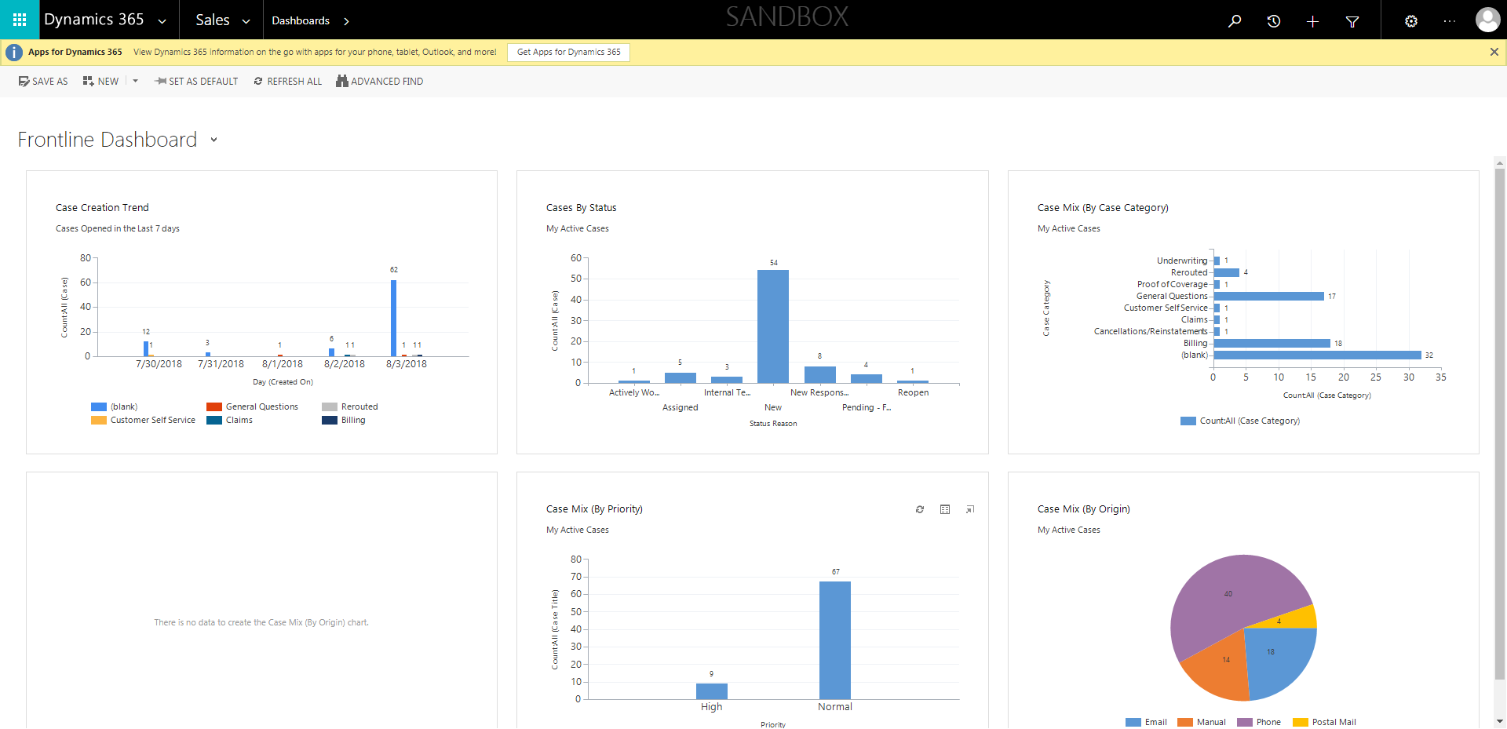

CaseManagement_CreationOfCase_Instance23_06-Aug-2018_02-54-06_AM_MouseClickActionMoveToElementBycssSelectorspanTabSFA.png

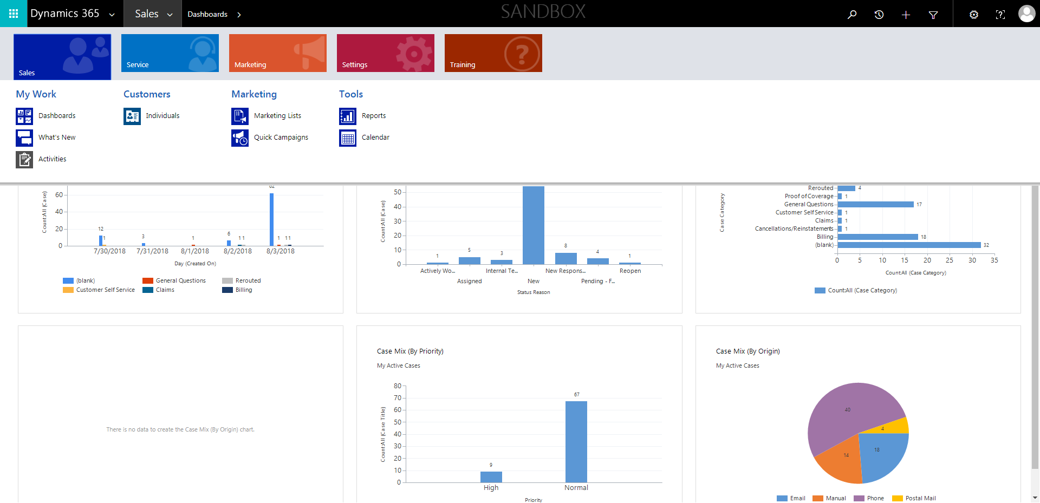

CaseManagement_CreationOfCase_Instance23_06-Aug-2018_02-53-40_AM_EnterTextAction.png

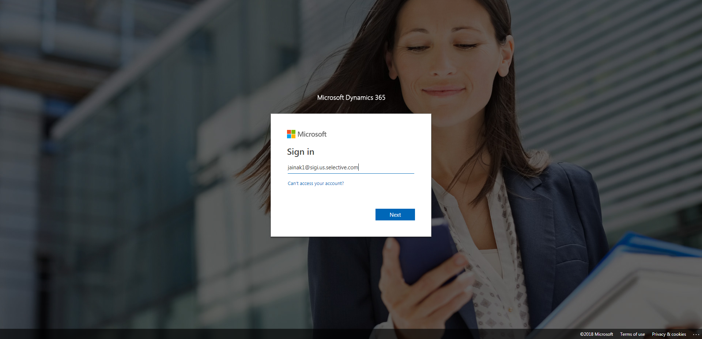

CaseManagement_CreationOfCase_Instance23_06-Aug-2018_02-53-38_AM_MouseClickActiononStaleElement.png

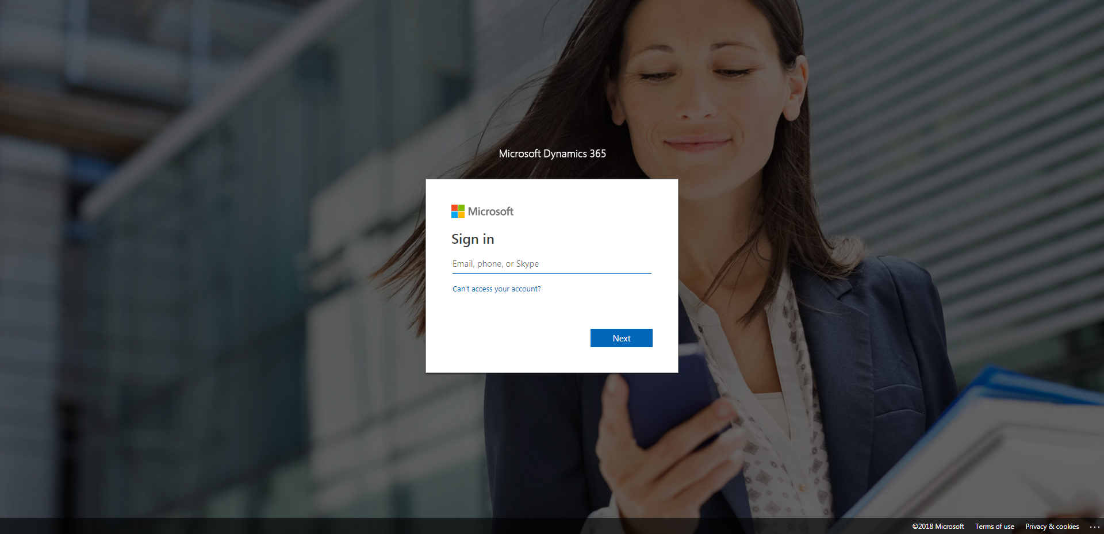

CaseManagement_CreationOfCase_Instance23_06-Aug-2018_02-54-08_AM_MouseClickActionMoveToElementByxpathimgaltServiceparentspan.png

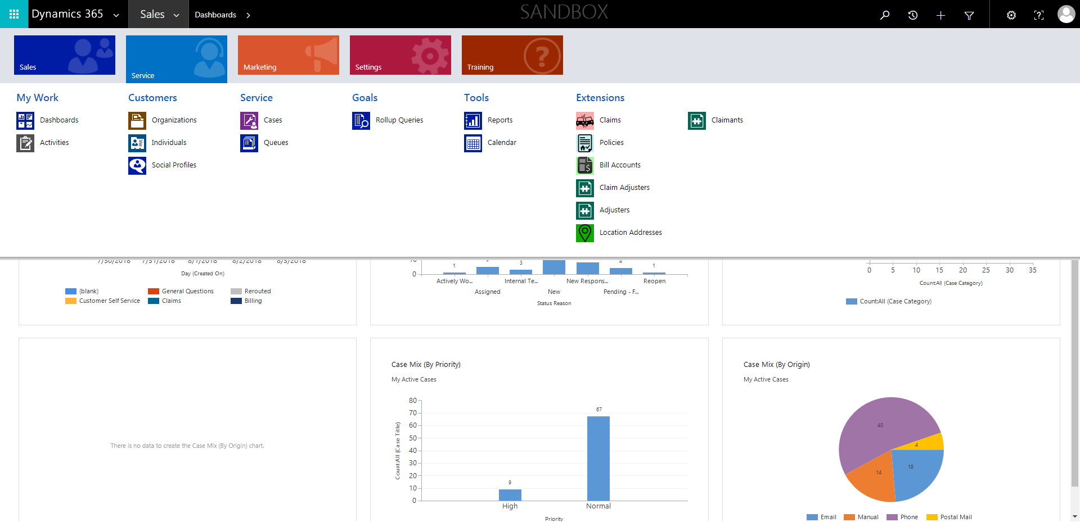

CaseManagement_CreationOfCase_Instance23_06-Aug-2018_02-53-41_AM_MouseClickActiononStaleElement.png

